EAST SUSSEX SUNDAY CROSS-COUNTRY LEAGUE
Warren Hill, Eastbourne.
(Staged by Hailsham Harriers Under UK Athletics Rules – permit: 181:18)
SUNDAY 16TH December 2018
Start As in previous years – the entrance to Black Robin Farm. Parking in Warren Hill Car Park. Approx 500M from car park to start. Finish is far side of Warren Hill Car Park.
Directions From the West (coastal road) head towards Eastbourne via the A259, through Seaford, Exceat, Friston and East Dean. About 2000M after East Dean turn right onto B2103 (signposted ‘Seafront, Beachy Head’). After about 1000M on your right is Warren Hill Car Park (see map below).
From the East come along Eastbourne Seafront, past the Pier, when you reach the end of the seafront road (the steep downs will be in front of you) the road bends round to the right (Upper Dukes Drive), follow this windy road uphill. At the ‘Give Way’ sign turn left (there is no signpost here), go straight past the left turn to Beachy Head, once past the turning after about 400M on your left is Warren Hill Car Park (see map below).
From the North (A27/A22 approach) head towards Eastbourne via the A2270, through Willingdon and over the roundabout (signposted ‘Town Centre’, ‘Seaford (A259)’, ‘Old Town’, ‘Beachy Head’). About 800M after the roundabout at traffic lights turn right onto Victoria Drive (signposted ‘Seaford (A259), ‘Beachy Head’). Follow for about 2000M (warning speed camera after about 500M on Victoria Road!) until you start to go uphill and reach traffic lights. At traffic lights turn right onto East Dean Road (A259), (signposted ‘Seaford (A259)’, ‘Beachy Head’). Follow the road up a very steep hill and past the golf course on your right. Once past the golf course after about 500M turn left onto B2103 (signposted ‘Seafront, ‘Beachy Head’). After about 1000M on your right is Warren Hill Car Park (see map below).
Sat Nav post code for Black Robin Farm (500M from Warren Hill Car Park) is BN20 7XX
Car parking DUE TO SIZE OF CAR PARK PLEASE CAR SHARE.
Parking is in Warren Hill Car Park (signage will be erected on the road to show the entrance).
Please arrive by 09:45 at the latest to allow time for registration and getting to the start, earlier if you have Juniors running.
Additional parking (for a fee) is available in car park just prior to Beachy Head pub, from Warren Hill car park turn right onto B2103, after about 400M turn right, signposted ‘Beachy Head’, after about 1600M, car park is on right, signposted ‘Countryside Centre’)
Course
Juniors : Under 11’s & 13’s - Out and back, downhill at start, uphill at finish, distance about 2200m (start at far end of Warren Hill Car Park).
Under 15’s & 17’s - Out and back, downhill at start, uphill at finish, distance about 3800m (start and finish at far end of Warren Hill Car Park).
Seniors : 1 full lap plus section between start (Black Robin Farm) & finish (far end of Warren Hill Car Park) again, slight hills, total distance about 8000m.

Please note Seniors race is not suitable to wearing spikes as at Cornish Farm (about 3600m) there is 20M section on a concrete road and at Beachy Head Road (about 6500m) there is 250M section on concrete road
Start time Juniors (both races) 10:00 am Seniors 10:30 am

Entry If pre registered for all 6 league races please ensure you sign in at Registration
Payment on the day £4:00.
Non-affiliated runners aged 17+ years will be charged a supplement of £2 to meet UKA licence regulations.
Club vests must be worn for runners to count for their team.
Please note competitors must NOT attempt to run with their dog !!!!!!!!!!!
Changing & Toilets Sorry, none available (nearest public conveniences are in car park just prior to Beachy Head pub, from Warren Hill car park turn right onto B2103, after about 400M turn right, signposted ‘Beachy Head’, after about 1600M, car park is on right, signposted ‘Countryside Centre’)
First Aid Phoenix Medical Services will be present by the start/finish
Maps on the next Page…..

From the North
From the East

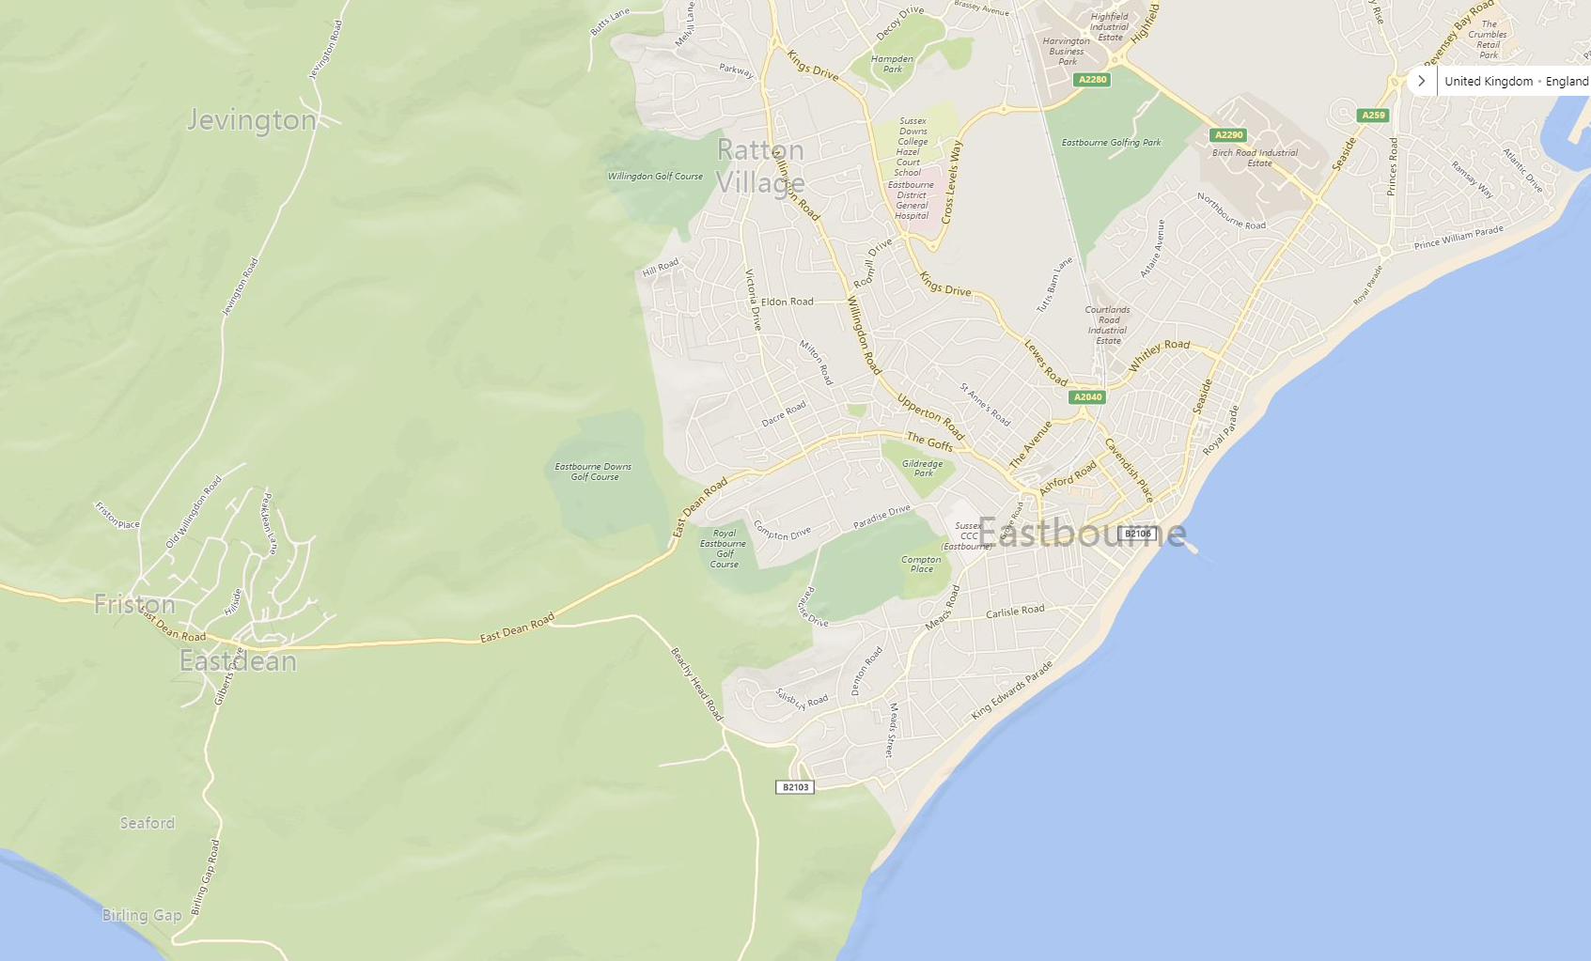
From the West
Warren Hill Car Park and Finish here (500M to Start)
Warren Hill
Start here (entrance to Black Robin Farm)

Additional parking (for a fee) - Beachy Head Car Park (1600M to Start, 2100M to Warren Hill Car Park and Finish)

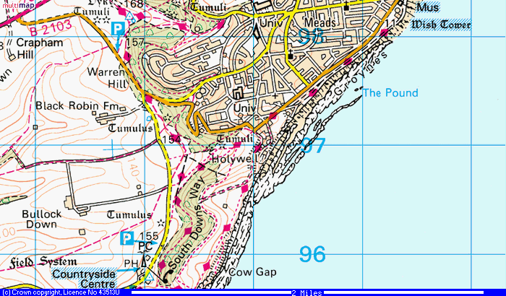

Warren Hill Car Park and Finish here walk from here

Warren Hill Start here

Additional parking here (for a fee) - Beachy Head Car Park (1600M to Start, 2100M to Warren Hill Car Park and Finish)

